Fall Flowing Using Raspberry Pi

* **AditiVaidya (19598)**
* **Github Link :** https://github.com/Aditigv/Embedded-Systems/blob/d8dac647892ec2b5d5351adbd6cc6dd16e60c72d/aditivaidya.mp4

## 1.0 Introduction

When the network connection is once established using ethernet cable between raspberryPi and the laptop. We can start programming using which mostly is inbuilt Thonny Python IDE editor.

## Objective

The main objective is to built the LED fall flowing circuit with Python programming using the Raspberry Pi 3 model B development board.

## Requirement

* 1 * Breadboard
* Jumper wires
* 1 * Raspberry Pi (I am using Raspberry Pi 3 Model B)
* 8 * 220Ω Resistor
* 8 * LED

## Principle

The on-off pattern can simulate voltages in between full **on** (3.3 Volts) and **off** (0 Volts) by changing the portion of the time when the signal is on versus the time that the signal is off.

## Working

1. 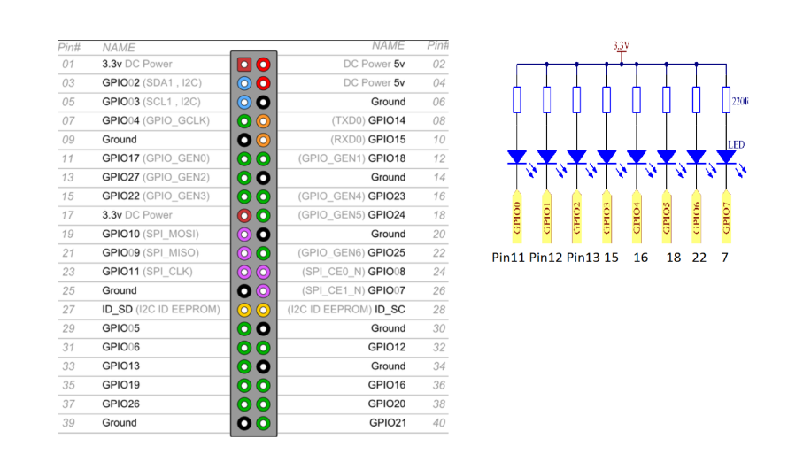Once the wireless connection is established then open thonny Python IDE which mostly is pre installed in raspberry Pi’s.
2. Make sure the Python library is uploaded and running .
3. Type in the program, and check for any errors.
4. Run the program .
5. Check for LED .

## Executed and Debugged

